Python List

Python Variables

Python For Loop

Algorithm / Logic

**CODE BASED ON OUR ALGORITHM**

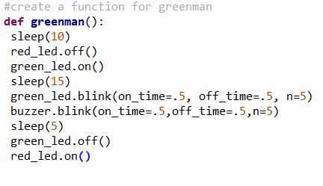

**THE ALGORITHM/LOGIC**

When someone press the button

There will be a 10 seconds delay before the pedestrian can cross

After the 10 seconds delay, the red light will go off

And the green light will come on

Give pedestrian 15 seconds normal walk time, followed by a time running out alert

Time running out alert is:

Blink the green light 5 times

Blink the buzzer 5 times also

Each blink is 1 seconds long

This will add up to 5 seconds

After which green light goes off

Red light comes on